|  |  |  |  |
| --- | --- | --- | --- |
| **SVKM's-IOT, Dhule**Shri Vile Parle Kelavani Mandal's  **INSTITUTE OF TECHNOLOGY**  **DHULE (M.S.)**  **DEPARMENT OF COMPUTER ENGINEERING** | | | |
| **Subject :** Java Programming Lab (Seminar-I) | | | Remark |
| **Name :**  Ansari Asharul Ameen Naeem Ahmad | | **Roll No. :** 63 |
| **Class:** SY. Comp. Engg. | **Batch : S4** | **Division: A** |
| **Expt. No. :**02 | **Date : 22/8/2024** | | Signature |
| **Title :**  write a java program to demonstrate operators | | |
|  | | |
|  | | |

**CODE1:**

import java.util.Scanner ;

class scan {

public static void main(String[]args){

Scanner obj = new Scanner (System.in);

int x;

String d;

System.out.println("Enter Roll no");

x=obj.nextInt();

System.out.println("Enter Name");

d=obj.next();

System.out.println("Rollno="+x+"Name="+d);

}

}

**OUTPUT:**

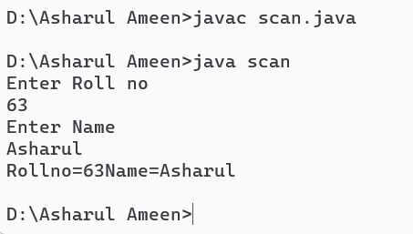

**CODE2 : relational**

import java.util.Scanner;

class operator {

public static void main(String[]args){

int a,b;

Scanner obj = new Scanner (System.in);

a = obj.nextInt();

b = obj.nextInt();

System.out.println("a>b"+(a>b));

}

}

**Output:**

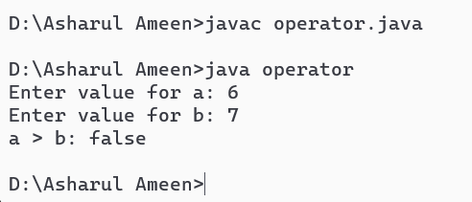

**CODE 3 : logical**

import java.util.Scanner;

class relational {

public static void main(String[]args){

int a;

int b;

int c;

Scanner obj = new Scanner (System.in);

a = obj.nextInt();

b = obj.nextInt();

c=obj.nextInt();

System.out.println("a>b and c>a"+(a>b && c>a));

}

}

**Output:**

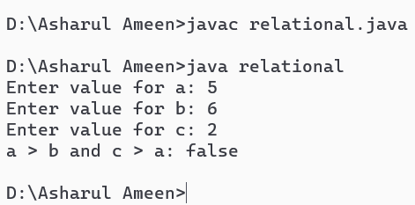

**CODE 4 : arithmetaic operators**

import java.util.Scanner;

class arith{

public static void main(String[]args){

int a;

int b;

Scanner obj =new Scanner(System.in);

a= obj.nextInt();

b=obj.nextInt();

System.out.println("The value of a+b is"+(a+b));

}

}

**Output:**

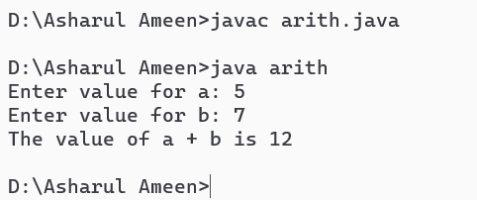

**CODE 5: bitwise operators**

public class BitwiseOperators {

public static void main(String[] args) {

int a = 5;

int b=3;

int andResult = a & b;

System.out.println("a & b = " + andResult);

int orResult = a | b;

System.out.println("a | b = " + orResult);

int xorResult = a ^ b;

System.out.println("a ^ b = " + xorResult);

int notResult = ~a;

System.out.println("~a = " + notResult);

int leftShiftResult = a << 1;

System.out.println("a << 1 = " + leftShiftResult)

int rightShiftResult = a >> 1;

System.out.println("a >> 1 = " + rightShiftResult);

}

}

**Output:**

